**DHCP:**

Dynamic Host Configuration Protocol (DHCP) is a system for assigning Internet Protocol (IP) addresses to each network device (known as a host) on an organization’s network. A host may be a desktop computer, a laptop, a tablet, a mobile device, a thin client, or other types of devices.

**DNS:**

The Domain Name System (DNS) is the phonebook of the Internet. Humans access information online through domain names, like google.com or facebook.com. Web browsers interact through Internet Protocol (IP) addresses. DNS translates domain names to IP addresses so browsers can load Internet resources.

**Network Design of DHCP and DNS:**

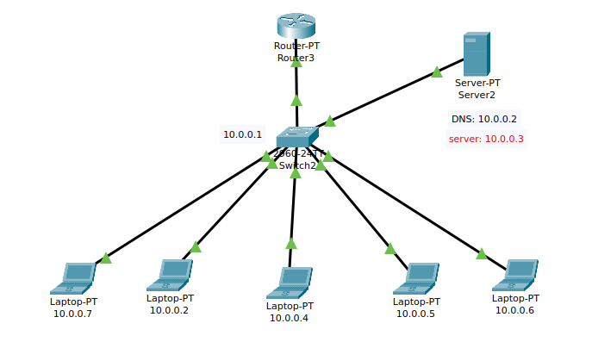

**Configuration of DHCP:**

Use 1 Router (10.0.0.1), 1 Switch, 1 DNS Server (10.0.0.2), 1 Server (10.0.0.3), and 6 Laptops.

* Subnet Mask: 255.0.0.0
* Default Gateway: 10.0.0.1 (Router)
* DNS Server: 10.0.0.2
* Server IP: 10.0.0.3

**Router Configuration Command :**

**Router 3**

en

conf t

int fa0/0

ip add 10.0.0.1 255.0.0.0

no shut

exit

ip dhcp pool Lab_report

network 10.0.0.0 255.0.0.0

default-router 10.0.0.1

dns-server 10.0.0.2

ip dhcp excluded-address 10.0.0.200

exit

**Output :**

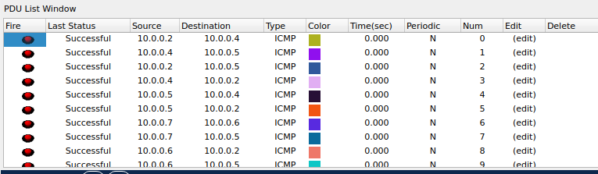

**DNS Configuration step :**

1.First of all we take 2 PCs and 1 DNS server and connect every device by using cable.

2. Configure IP Address: We assign an IP address to the server by going to Desktop > IP Configuration.

3.Enable DNS Service: Go to Services > DNS on the server, turn on the DNS service, and add domain names with their corresponding IP addresses.

4.Configure Client Devices: For each client device, go to Desktop > IP Configuration and set the DNS server’s IP address.

5.After that we verify and troubleshoot for check the server status and logs to confirm DNS is working, and troubleshoot any issues.

**DHCP and DNS Packet Tracer File :**